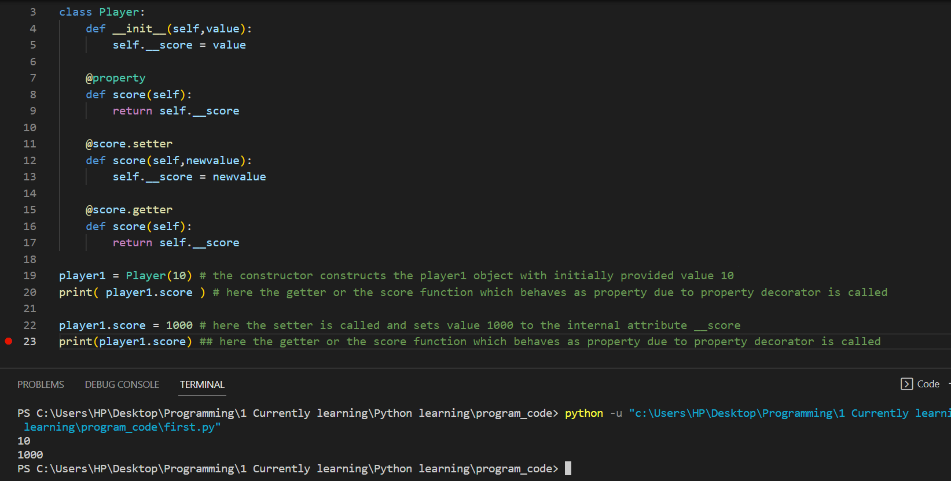

**ABSOLUTE LAW**

**Do not try to overwrite the internal attributes directly from outside the class**

Use the setters, since the setters functions change the internal attributes values from inside the class

Here in above

1. We use __ double underscore to name the internal attributes variables
2. We made a method with the same name as the internal attribute variable but one without __ double underscore, using the @property decorator which would make the function to behave as the property of the class
3. We then made the setter
4. We then made the getter

We could have also done this

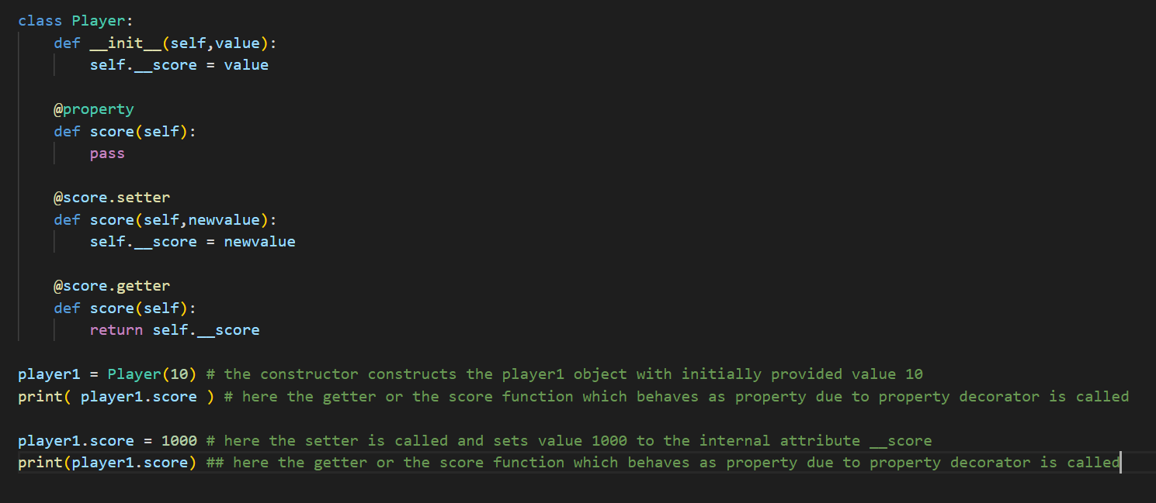

Here we just make the score method to behave as a property

Unlike above

Where we made score behave as a property and also as a getter which would return the value of internal attribute variable __score

**My own convention**

1. Pahila internal attributes variable agadi __ double underscore rakhaeraa banaunae
2. Ani same name as internal attributes but without double underscore, bata @property decorator use garaeraa methods banaunie, ani tes paxi same name bata getters raa setters banaunie